TOR (The Onion Router)

Muhammad Amir(13L-4079)
Department: Computer Science , FAST NUCES , Lahore
muhammadamir252@gmail.com

Saad Ali (14L-5867)
Department: Computer Science , FAST NUCES , Lahore
saad.baloch08@yahoo.com

Table of content:
  - Abstract
  - Background
  - Introduction

2.1Critical Evaluation of TOR Network and Browser

2.2 Working Principle
2.3 Configuration of two nodes
2.4 Identifying the real source/User
3.1 Conclusion
4.1 References

1.1 Abstract

The overall purpose of the study was to critically evaluate the onion router network and browser and to discuss TOR’s working principle. There is no research on configuration of two participatory nodes which is a major part in TOR’s research. This research comprises of evaluation of the onion router, TOR’s working principle, configuration of two participatory nodes and classification of methods of identifying the real source/user.

1.2 Background

It was developed in 1995 by United States Naval Research Laboratory employees including Paul Syverson (Mathematician) and other computer scientists in order to protect US intelligence communications online. The alpha version of TOR was developed in 2002. Its use was to send data anonymously.

1.3 Introduction

The term TOR stands for The Onion Router. It was developed in 1995. The onion routing is hidden communication technique over a network. Communication is first encrypted and then sent through multiple networking nodes which are called onion routers. These onion routers then creates circuit of nodes. These onion routers are used by different organizations such as government as well as private especially by intelligence organizations. On the other side these routers are also used by hackers, criminals, drug dealers etc. It is a hidden service in which identity of the user is not visible to anyone. The name onion is used because it adds the layers on the very first node having data and headers and then peel of or unwrap the layers by the onion routers one by one at each step and transfers the data to the destination node. The original message of the user remains hidden because it is transferring from one node to the next and there is no intermediate node which knows the origin and destination of the data which allows the sender to remain anonymous/hidden. Also the message is transmitted through several layers of encryption, the job of last node is to decrypt the final layer and to pass the message or data to the receiver or destination.

2.1 Critical Evaluation of TOR Network and Browser

TOR network is basically an underground network that is anonymous. It is popular due to its anonymity. TOR protects identity of the user. TOR consists of three different types of nodes which are Directory servers, Exit points and Internal relays. When a person is connected with a TOR network, he acquires the current list of relays from the trusted directory servers. The addresses of these servers includes basic configuration of files with the client. After retrieving that list, the user determines the optimal route for traffic across TOR network and then finally it terminates at exit node. The whole mechanism consists of the users pc, the relay to which the user is connected and the relays in path before reaching its destination or exit node. It is different from the traditional IP forwarding on internet routers. In TOR network all of the traffic will follow the same route which is different from the operation of I2P routes. The client first exchanges the encrypted keys with the first router it connects to and begins encrypted traffic. It gets wrapped around the data. And it gets decrypted again at the exit node and it is then forwarded to the regular internet. In this way, it maintains our privacy online. Your entry knows who you are but your exit node doesn’t know where the request is coming from. The browser commonly used for accessing the TOR’s network is called TOR browser. Through this browser we can use TOR network and can safely browse the internet without letting know our identity. There are some servers that are only accessible within the TOR network. Our regular network also provides anonymity but in a different way.

2.2 Working Principle

TOR’s working principle is simple yet complex. It consists of several steps. The overview of which is as follows
- Define route
- Construct the anonymous connection
- Move and encrypt the data through the connection
- Destroy the anonymous connection
Suppose we have a client and a server. First of all, client obtains a list of TOR nodes using his browser from the directory server. Then it picks a random path to the destination server. In case if he wants to access another site then the browser will select another random path. After selecting the path, TOR makes the connection till its exit node. The client first exchanges the encrypted keys with the first router it connects to and begins encrypted traffic. It gets wrapped around the data. And it gets decrypted again at the exit node and it is then forwarded to the regular internet. In this way, the server knows the address of the last (exit node) but not the original IP of the client.

2.3 Configuration of two Nodes

After defining the route and making the connections, the data now have encrypted layers upon it. These encrypted layers are added before going into the anonymous network. Now the relays/nodes in the network unwrap the layers and pass the data along with other encrypted layers to the other. At the exit node, all the layers get peeled/unwrapped. The data has now no layers on it. It is then passed on to the destination via the regular internet. Now, we will explain it through an example.
Step 1) Let’s suppose the path chosen randomly by TOR is 4, 3 and 5 mentioned in the image below.
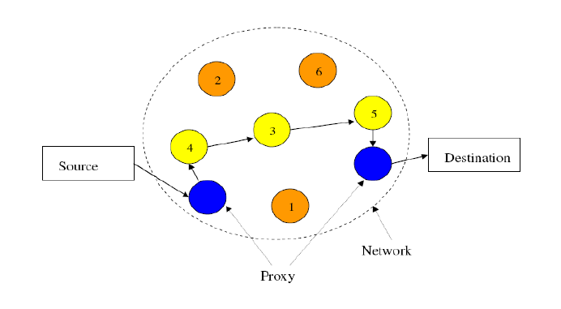
Step 2) After determining the path, the data is encrypted by adding the layers to it.
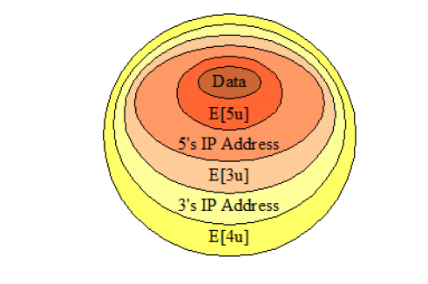

Step 3) This onion is passed onto the hidden encrypted network. Now each relay will be given by the private key to find the next router IP address. In this example, router 4 will decrypt E[4u] layer by using its private key in order to find the next router’s IP address that is 3.
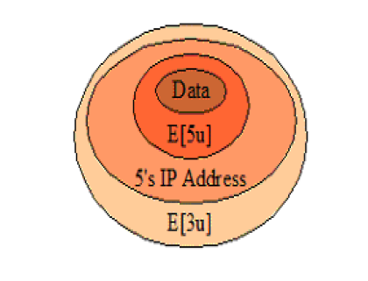

Step 4) Now router 3 will decrypt the E[3u] layer using its private key to find next IP address and encrypted.

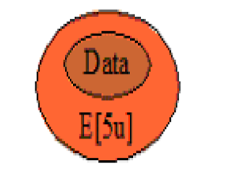
Step 4) Router 5 will decrypt E[5u] layer using its private key to get the data. Now the data is sent to the destination by the router 5 to the regular internet.



2.4 Identifying the real source/user

Identifying the real source or user is quite a difficult task as no one has ever successfully found a solution to this problem. The investigators, ISI and other intelligence agencies are looking for a way to find the real source or user so that they can rescue them for their acts but still hasn’t found a way to that. It is possible but it is not that easy. It is easy to find the IP address of the TOR’s exit node than any other node in the network. This is because the exit node removes the last layer of encryption and send the data directly to the destination via regular internet. But the exit node IP address may not be useful as we cannot still have idea where the data is really coming from. One way could work is having a service that access a resource outside of TOR and make the user access this service often.
Another way can be to monitor cookies on the user pc. But the user can be so smart because they can disable cookies while surfing deep web. There could be the involvement of java script in it. But it can also be set to not allowed by the user.
In short, it is really hard to get to the original source.

3.1 Conclusion

To put the above discussion into a nutshell, we can say that TOR network is very useful for intelligence purpose and to keep data confidential but despite of that there are several disadvantages too as it is anonymously being used for cybercrimes. TOR keeps real source protected and we can reach destination without tracing the real IP with the help of relays defined by TOR. Each relay decrypts by the private key and pass the data/onion to the next router/relay. And by this we pass our data to the destination. It is difficult to get the real source IP yet possible.

4.1 References
https://en.wikipedia.org/wiki/Tor_(anonymity_network)#History
https://www.quora.com/Is-it-possible-to-find-out-the-real-IP-address-of-a-Tor-browser-user.

https://www.ivpn.net/privacy-guides/an-introduction-to-tor-vs-i2p.

VIDEO LINK (YOUTUBE)

https://youtu.be/bYdX0_LugHg

